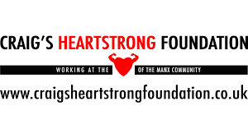

St Ninian’s Senior Prefects are raising money to help support and raise awareness of the Craig’s Heartstrong Foundation, a charity that raises money to fund free heart screenings for Men and Women between the ages of 14 and 35.

These reuseable bottles are an alternative to single-use plastic bottles and to help improve sustainability.

**You can purchase one of these bottles via the ParentPay portal for £2.50 or with cash at Reception, all proceeds go towards the charity.**

For more information about the foundation please visit the website: